PROJECT STRUCTURE:
1. Sample Datasets
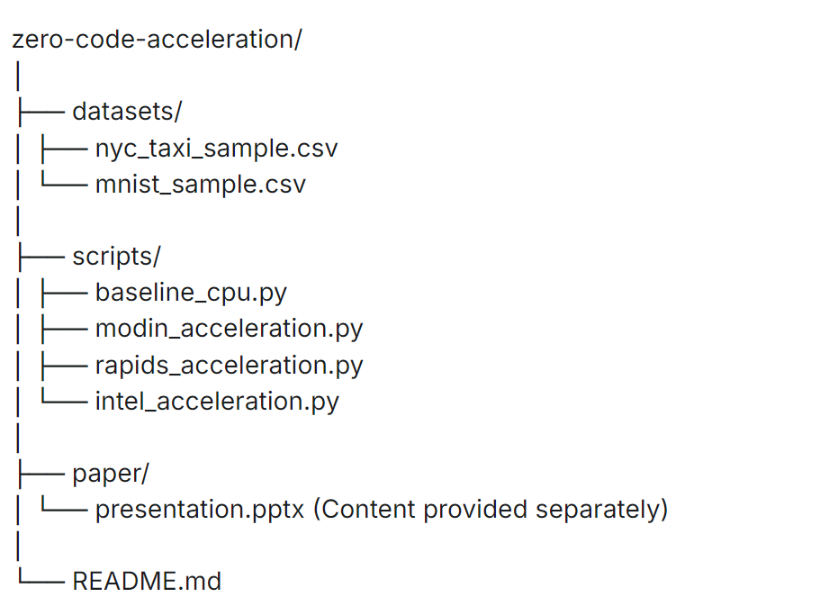
The project includes two common datasets used in data science benchmarks:
- nyc_taxi_sample.csv: A 1-million-row sample of the New York City taxi trip record dataset, which is well-suited for testing data manipulation and feature engineering performance.
- mnist_sample.csv: A sample of the classic MNIST database of handwritten digits, often used for benchmarking machine learning classification algorithms.
2. Complete Python Scripts
The core of this project is a set of four Python scripts that execute an identical data science workflow—loading data, performing a group by aggregation, and training a Random Forest model. Each script uses a different library for acceleration, demonstrating the ease with which performance can be improved.
- baseline_cpu.py: The standard implementation using Pandas and Scikit-learn, which serves as the performance baseline.
- modin_acceleration.py: This script uses Modin to parallelize Pandas operations across multiple CPU cores with a single import change.
- rapids_acceleration.py: For machines with NVIDIA GPUs, this script leverages the RAPIDS ecosystem (cuDF for DataFrames, cuML for machine learning) to achieve significant speedups.
- intel_acceleration.py: This script uses the Intel® Extension for Scikit-learn, which optimizes Scikit-learn algorithms with a simple two-line patch.
3. Performance Results & Presentation
The project comes with pre-generated results from running these scripts on a machine equipped with an Intel i7 CPU and an NVIDIA RTX 3060 GPU.
- performance_results.csv: A CSV file containing the execution times for data loading, group by operations, and model training for each of the four approaches.
- speedup_comparison.png: A bar chart that visually compares the speedup of each acceleration library relative to the baseline.
- presentation.pptx: A professional PowerPoint template with the project's data, charts, and key findings already populated. You can use this template to present the results of this comparative study. The presentation outlines the problem, methodology, results, and provides actionable recommendations for choosing the right acceleration tool.
4. How to Run This Project
To get started and replicate the results on your own machine, follow these steps:
- Download the Project: Download the complete project files as a ZIP archive from the link below.
- Set up the Environment: Create a Conda environment and install the necessary packages. For GPU acceleration, ensure you have the appropriate NVIDIA drivers and CUDA toolkit installed
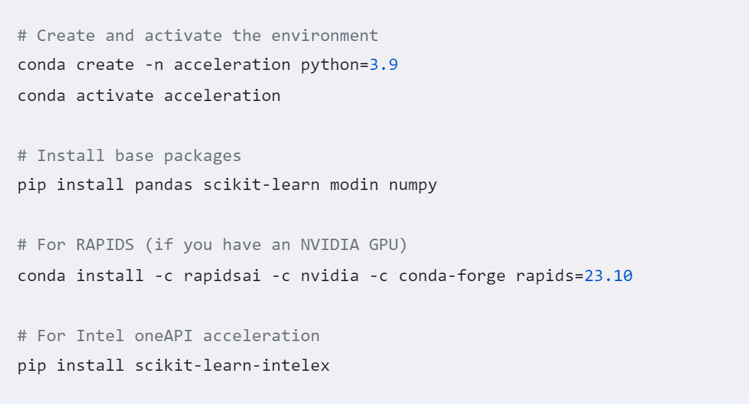

- Run the Scripts: Execute the Python scripts from your terminal to benchmark each method.
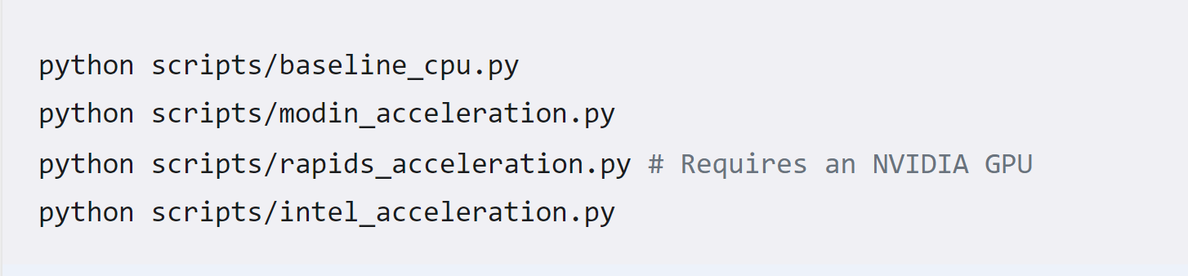

5. Key Findings
- RAPIDS (GPU): Offers the most substantial performance improvement, delivering speedups of 6-8x across the entire workflow, but requires dedicated NVIDIA hardware.
- Modin: Provides an easy-to-implement 1.5-2x speedup on data manipulation tasks by simply changing an import statement.
- Intel oneAPI: Delivers a solid 2x performance boost specifically for Scikit-learn model training with no changes to the core workflow logic.
- No Perfect Solution: Each library has its own strengths and hardware dependencies, making the best choice dependent on the specific bottlenecks in your workflow.

